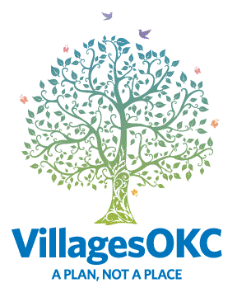
VIRTUAL VILLAGE VISION

Edition 23
April 2021

MESSAGE FROM MO

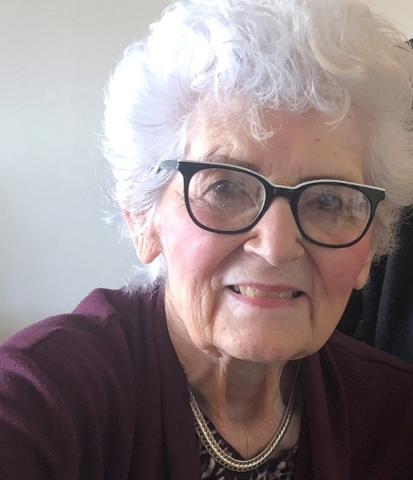
The POWER of REACHING OUT

VillagesOKC is all about reaching out to others. Reaching out and helping others is extremely powerful because it benefits both the giver and the receiver. WHAT AN OPPORTUNITY! Reaching out to others allows me to improve my own mental health by getting the focus off myself and help someone else too.

The Apostle Paul was imprisoned and in chains. But instead of feeling sorry or complaining about his situation and wasting time, he asked for good books to read to improve his mind and spirits. Then he asked for paper and pen. The result were letters of encouragement and instruction. Many of the letters were simply caring about and checking on his friends. Today those letters make up thirteen books of the New Testament in the most printed, most translated, most purchased book in the world.

Would Paul have written letters if he had never been imprisoned? What if I used the time I have to encourage and uplift someone? What if there was an entire village of people who were encouraging and uplifting each other? What if joy, positivity, creativity, learning new tasks, embracing change and meeting new friends were happening every day?

Sounds like a dream? Voilà!

From Guthrie to Norman and Choctaw to El Reno including all of greater Oklahoma City, VillagesOKC is demonstrating the power of reaching out to others. Take action; check us out at a Gathering at Johnnies. Call today to be a part of the most interesting, most creative way to age positively in greater Oklahoma City.

VILLAGESOKC MISSION STATEMENT

We are virtual neighbors enabling mature adults to come together to learn, plan and serve with spirit and dignity.

As in any small town, this is a neighborhood who is connecting the good people of Greater Oklahoma City and trusted businesses to help each other with what we can when we can. It is organized friendships with appropriate boundaries.

VillagesOKC offers friendships to fill the gaps where family, church and existing friends leave off. VillagesOKC also offers trusted information and referral sources for congregations and pastors.

Learning includes creative MindRAMP Brain Classes and MindRAMP Brain Academy. Planning includes the exclusive VillagesOKC GIFT four week-workshops in intimate groups of 12. Strategic 2021 plan is to hold 33 classes in locations throughout greater Oklahoma City. Planning also includes Money Matters and Health Matters. Serving includes transportation, Buddy Checks, Porch Pals, HeShed, Monthly Gatherings in Edmond and Oklahoma City and Trusted Business List access.

VILLAGESOKC APRIL SCHEDULE

For the most up-to-date information, check the VillagesOKC online calendar with this link: VILLAGESOKC CALENDAR

For all Zoom meetings, after registering,
you will receive a confirmation email containing information about joining the event.
- Pickleball – Mondays and Wednesdays – 9:30-11:30am – Jackie Cooper Gym, 1024 E Main St, Yukon
Tuesday and Thursday – 11:00-1:00pm – Yukon Community Center, 2200 S Holly Ave, Yukon
(Masks are required at both locations)

- Wednesday, April 7, 2021 – My Love Affair with the Brain – 10:00am – Whipped Bakery
CLICK HERE to let us know you’ll be there!
3820 N. MacArthur Blvd – Warr Acres
(See event description on page 4)

- Thursday, April 8, 2021 – Senior Living Truth Series – 10:00am-11:30am
Quail Creek Golf and Country Club - Part 1: The Psychology Behind Letting Go
3501 Quail Creek Rd, OKC
(See event description on page 5)

- Saturday, April 10, 2021 – Edmond Gathering @ Johnnie’s Charcoal Broiler – 12:30pm-2:30pm
CLICK HERE to let us know you’ll be there!
33 E. 33rd St., Edmond

- Tuesday, April 13, 2021 – Women’s Coffee – 10:00am – Whipped Bakery
CLICK HERE to let us know you’ll be there!
3820 N. MacArthur Blvd – Warr Acres
- Tuesday, April 13, 2021 – Money Matters with Thrivent Financial – 1:00pm-2:00pm
CLICK HERE to register for this event

- Wednesday, April 14, 2021 – MindRamp Workshop – 1:30pm-3:00pm
Level 3: CogWheel Overview/Physical Exercise/Mental Stimulation
(Registration has ended for this event)

- Saturday, April 17, 2021 – NW OKC Gathering @ Johnnie’s Charcoal Broiler – 12:30-2:30pm
CLICK HERE to let us know you’ll be there!
6629 NW Expressway, OKC

- Wednesday, April 21, 2021 – My Love Affair with the Brain – 10:00am – Whipped Bakery
CLICK HERE to let us know you’ll be there!
3820 N. MacArthur Blvd – Warr Acres
(See event description on page 4)

- Wednesday, April, 21 2021 – Christian Women’s Lunch – Quail Creek Country Club – 12:00pm-1:30pm
3501 Quail Creek Rd, OKC – Three – course lunch – $22 or $27 at the door. RSVP to Peggy – 405.343.0079

- Thusrsday, April 22, 2021 – Shredding Party – Buckelew Realty Group & OKC Mature Moves – 10:00am-12:00pm
4513 Memorial Circle, OKC
(See event description on page 6)

- Wednesday, April 28, 2021 – New View Low Vision Tour – 9:00am-12:00pm
CLICK HERE to register for this event
4301 N. Classen Blvd, OKC
(See event description on page 7)

- Wednesday, April 28, 2021 – MindRamp Workshop – 1:30pm-3:00pm
Level 3: Social Engagement/Stress Management/Diet & Nutrition
(Registration has ended for this event)

- Thursday, April 29, 2021 – VillagesOKC Virtual Quarterly Town Hall – 3:00pm-4:00pm
CLICK HERE to register for this event
air April 7&21 10:m
MORE OPTIONS FOR GIFT WORKSHOPS

We’ve heard your requests for more options regarding the GIFT Workshops. We are happy to announce that we are now offering the standard 4-week (1 ½ hour each session) option with workshops around the OKC area, 4-week Zoom options, small group workshops that can be held in your living room, dining room, coffee shops or other locations of your choosing and condensed 2 week (2 sessions – 4 hours each).

Here’s the best part! If you are a VillagesOKC member, the workshop only will cost you $20 (to cover the supplies) and your friends that are not members, can join for our special 2021 GIFT Membership price of $199. That gives them 1 year to check out VillagesOKC and covers their workshop fee. Contact Keri to discuss the GIFT Workshop options that would work best for you!

GIFT WORKSHOPS 2021

The GIFT is a four-week interactive workshop guiding participants through 12 key areas most impacted in a transition. Participants learn time-saving techniques, providing rapid access to key information when needed. Attendees receive the exclusive VillagesOKC GIFT Binder to keep, a trusted network of professionals with resources, and a safe and confidential environment providing support, encouragement, and direction.
The GIFT workshop dates for 2021:

Hosted by: Julie Davis – Concordia – Zion Lutheran Church – Tuesdays – April 6, 13, 20, 27 – 10:00am
Hosted by: Dr. Nikki Buckelew – Zoom – Saturday – April 17, 24, May 1, 8 – 10:00am
Hosted by: Marilyn Olson – VillagesOKC –Thursdays – April 22, 29 – 12:00pm (condensed 2-week workshop)
Hosted by Julie Davis – Concordia – Messiah Lutheran Church – Tuesday – July 6, Mondays July 12, 19, 26 – 6:30pm

Be prepared! EVERY VILLAGESOKC MEMBER, all your neighbors, church friends and club friends will want to enroll in one of these 4-week GIFT classes.
Call/text 405.990.6637 to reserve your spot today!

Now Scheduling 2021 Host Locations! All that is needed is seating and a bottle of water for 12 at a church, library, restaurant, insurance agency, realtor office, wellness center or country club. If you have a suggested location for the 4-week GIFT series, please call/text the office 405.990.6637 or email info@villagesokc.org!

Still on the fence about if you really need to take The GIFT Workshop? Check out these testimonials from other VillagesOKC members!
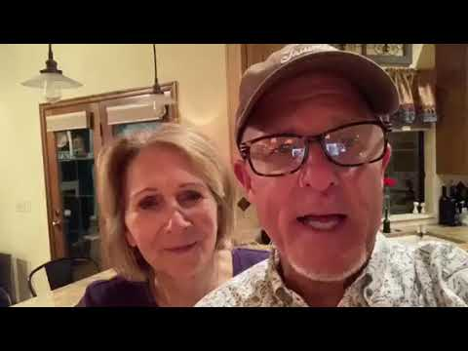
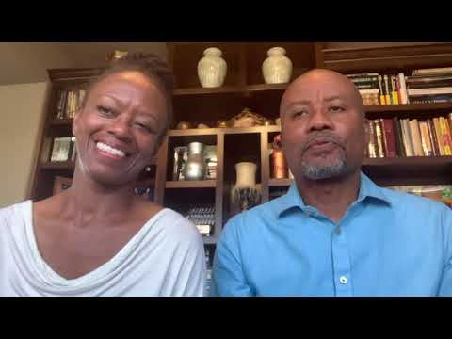

MY LOVE AFFAIR WITH THE BRAIN

Wednesday April 7 or Wednesday April 21 at 10:00am
CLICK HERE to register for April 7, 2021
CLICK HERE to register for April 21, 2021
Whipped Bakery Café – 3820 N. MacArthur Blvd – Warr Acres
Join is on Wednesday April 7 or Wednesday April 21 at 10:00am for a FREE showing of My Love Affair with the Brain. Whether you have watched this movie 5 or 500 times, there is always something new to learn. Grab a few friends who would be interested in watching this movie and learning more about VillagesOKC. Check out the preview below!
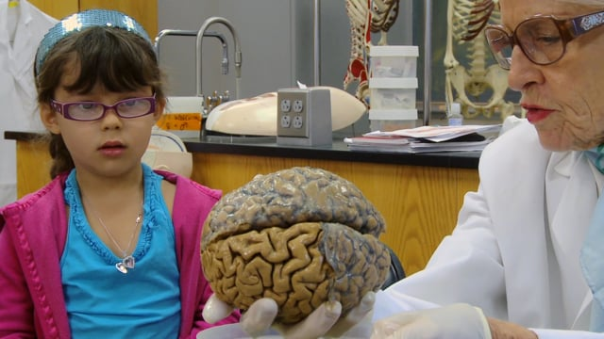
“My Love Aﬀair with the Brain” is a documentary that covers the brain, the passion of scientific discovery, the creation of modern neuroscience, Albert Einstein, women in science, and love—all via the life and research of beloved professor and YouTube celebrity, Dr. Marian Diamond.

Marian Diamond’s research demonstrated the impact of enrichment—a powerful new understanding of the brain that has literally changed the world, from how we think about ourselves to how we raise our children. Dr. Diamond demonstrated anatomically, for the ﬁrst time, what we now call plasticity and in so doing, shattered the old paradigm of understanding the brain as static and unchangeable.

PROJECTS NEEDING YOUR HELP

VillagesOKC office team coordinates 435 various activities for VillagesOKC members across Oklahoma City.

- If you enjoy organizing, tackling an afternoon project or a several afternoon projects, give the VillagesOKC office a call and set a time to meet with Mary.

- Caroline is looking for help recruiting and getting to know new members.

- Marilyn is looking for volunteer to schedule and coordinate the GIFT classes and make sure attendees know where and when workshops are located.

- Another volunteer is needed to schedule GIFT Video Testimonials of those who have gone through the 4 week workshop.

- Mary is looking for volunteers to organize records, write thank you notes, create a history album, file news clippings, and even straighten up the storage cabinet.

- Keri is looking for a volunteer to write sections of the newsletter and another to do general filing.

- Gaylene is looking for a volunteer to assist her with Porch Pals.

- The PR team will soon need a volunteer to assist with articles and photos.

- The team is looking for a volunteer to organize our Trusted Business Listings and do data entry.

- The team is looking for a volunteer to begin interviewing members and sponsors.

- Another volunteer is needed to coordinate the calendar – this could be monthly for a quarter (3 months) or for the remainder of the year.

Most projects have a beginning and an end; a few are on-going either weekly or monthly. A few projects could be done at home. Contact the VillagesOKC office for more information or to set up a time to volunteer.

As sponsors of the Senior Living Truth Series, featuring a variety of educational events focusing on the unique and complex issues affecting mature Oklahomans, we are committed to empowering, educating, and equipping people to live their best lives.

Here are the details for the upcoming series:

Part 1: The Psychology Behind Letting Go (April 8th)
Despite all the signs that it’s time to simplify, many people struggle with letting go. Whether it’s saying “goodbye” to a home of many years or parting with the treasures inside, certain challenges are commonplace when it comes to downsizing, rightsizing, or relocating. In Part 1 we will take a deep dive into the human psyche and discuss ways to make letting go easier.

Part 2: The Downsizing Made Easy Method (May 13th)
This step-by-step method of downsizing was created by Dr. Nikki Buckelew and her team over two decades ago. Since then, they have helped hundreds of people successfully relocate both locally and nationally. Learn about the tasks, resources, and timelines associated with making a successful retirement move, along with tricks and tips for making it easier than you would expect!

Part 3: Best Solutions for Liquidating the Extra “Stuff” (June 10th)
Times have certainly changed when it comes to buying and selling used household items. With a marketplace flooded by new inexpensive furniture, stores full of trendy home decor, and second-hand housewares only a click away, liquidating a full house (or garage) of excess items requires a NEW and current day strategy.

Learn more about why garage sales are no longer as effective, changes in how estate sales are conducted, how to liquidate high end items, and how to donate specialty pieces.

Thursdays: April 8th, May 13th, June 10th – 10:00 a.m. – 11:30 a.m.
Quail Creek Golf and Country Club – 3501 Quail Creek Rd, Oklahoma City, OK 73120

JOIN FROM HOME OR IN PERSON: While caution concerning COVID-19 continues to be at the forefront for many, you can watch and/or listen from home.

Pre-registration is required. Call 405.563.7501 or visit www.seniorlivingtruthseries.com.
AMAZONSMILE WISHLIST

THE TRUTH ABOUT DOWNSIZING

If you are looking for a way to help the daily operations of VillagesOKC, now is a great time! We have an Amazon Wishlist. All you have to do is click on THIS LINK, and you will be taken to our wishlist. You’ll pick what you would ike to purchase, pay, and it automatically ships to the VillagesOKC office. We are updating this wishlist regullary so check back often to see what we need to help spread the VillagesOKC mission.

We also have the Amazon Smile account that supports VillagesOKC with all of your elligible Amazon and AmazonPrime purchases. To access our Amazon Smile, CLICK HERE, and it will take you to your Amazon account if you’re already signed in on that device. If you access the link from your phone and have the app, it will give you prompts on how to set it up where it’s a default option for all purchases!

If you need help to get this set up for your Amazon account, please contact Keri. Please feel free to share this link with all your family and friends!
THE GATHERING AT JOHNNIES

2nd Saturday of each Month (April 10) – Edmond Johnnies 33 E. 33rd St., Edmond
CLICK HERE to let us know you’ll be there!

3rd Saturday of each Month (April 17) – NW OKC Jonnies – 6629 NW Expressway, OKC CLICK HERE to let us know you’ll be there!

Purchase your food and come sit with VillagesOKC in our private dining room. Everyone, members and friends are welcome to attend this social gathering! Johnnie’s has a great selection of burgers, salads, hotdogs and gluten free options.

PLAN TO DO SOME SHOPPING ON APRIL 21

A valued monthly connection for VIllagesOKC is the Oklahoma City Christian Women and Men Luncheons. But the April 21 Spring Bazzar is especially buzzing with excitement. On April 21 at 11:30am, Quail Springs Country Club becomes a fun place to shop for unique gifts and the proceeds go to a fabulous local charity, Dress For Success. It’s a silent auction, bake sale, and a raffle, as well as boutique shopping. With a three course lunch ($22.50 with prior registration), attendees will hear Inspirational speaker, Leslie Cooper, telling of her battles with personality disorder, bipolar, PTSD, fibromyalgia, anxiety disorder and 23 years of addictions. She was told there was no hope. Until God intervened.
RSVP by April 17 to Peggy at 405.343.0079.

MEMBER SPOTLIGHT - SYBIL HALE WITH PROS MAKE READY SANITIZING SOLUTIONS

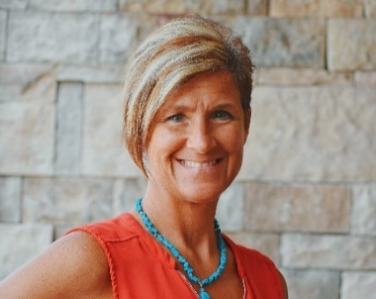
Suffering from those pesky allergens? A VillagesOKC member may be the answer. Sybil Hale owns PROS Make Ready Sanitizing Solutions which is a sanitizing business for businesses and homes. Her business specializes in reducing days lost from illness and in improving efficiency, focus and productivity. Who knew being clean was so important? As a VillagesOKC member, Sybil is also the absolute friendliest promoter of VillagesOKC, bringing in new members and trusted businesses. If you ever come to a MindRAMP Zoom or to a Saturday Gathering, you will see Sybil walking fast and connecting with everyone in the room.

SHREDDING PARTY WITH OKC MATURE MOVES

DRIVE THROUGH FREE SHREDDING

One of our Sponsors, Buckelew Realty and OKC Mature Moves, is hosting a FREE SHREDDING. April 22, 10:00am – 12:00pm. Unlimited room for boxes of paper, bags of paper, trunk loads of paper. You can leave in the paper clips and staples. The truck will be at the KELLER WILLIAMS REALTY, 4513 Memorial Circle, OKC (west of Mercy behind BancFirst.) Call Nikki at 405.708.7010 if you have questions.

TOUR NEW VIEW

Wednesday, April 28, 2021 – New View Low Vision Tour – 9:00am-12:00pm
4301 N. Classen Blvd, OKC
CLICK HERE to register for this event
Since 1949, New View Oklahoma has empowered individuals facing vision loss, to maximize their opportunities to live life without limits THROUGH ALL STAGES OF LIFE. For those with diabetes or macular degeneration and other vision diagnosis, New View accomplishes this with comprehensive low-vision rehabilitation services, with meaningful employment opportunities, and with engaging community programs. Come learn more about the wonderful resources in Oklahoma City. Elaine Wood, RN and Brenda Rice, RN, are organizing this amazing opportunity. Register with the link above or call the office for more information.

CONTACTING VILLAGESOKC

VillagesOKC – 3908 N. Peniel Ave., Ste. 340, Bethany, OK
Phone: 405.990.6637
E-mail: info@villagesokc.org
Website: www.VillagesOKC.org

Like us on Facebook! https://www.facebook.com/villagesOKC/
Follow us on Instagram! https://www.instagram.com/villagesokc/
Subscribe to our YouTube Channel! @VillagesOKC

We are very grateful to our sponsors whose regular giving provides a financial bridge for our operation. Please take time to look at the logos on the last page of the newsletter and reach out to thank these companies who recognize the value of the aging community. A handwritten note, email, or phone call with a message of “thanks” is a great way to tell them we care about their success too.
SPONSOR INFORMATION

- Providence Home Care
2831 NW 59th St, Oklahoma City, OK 73112
405.602.3295 – info@providencehcare.com
- Concordia Life Care
7707 W Britton Rd., Oklahoma City, OK 73132
405.331.6113 – Toll-free: 888.489.0075
- Thrivent Financial
1616 E 19th St # 101, Edmond, OK 73013
405.348.2371
- Buckelew Realty/OKC Mature Moves
2932 NW 122nd St #17, Oklahoma City, OK 73120
405.563.7101 – info@okcmaturemoves.com
- Gooden Group
2611 Kelley Pointe Pkwy, Edmond, OK 73013
405.715.3232
- Spanish Cove
11 Palm Avenue, Yukon, OK 73099
800-965-COVE (2683)
- MCM Insurance
2232 W Hefner Rd. Ste. A, Oklahoma City, OK 73120
405-842-0494
- Oklahoma Palliative & Hospice Care
8241 S Walker Ave #204, Oklahoma City, OK 73139
405.418.2659 – info@oklahomahc.com
- First Bethany Bank and Trust
6500 N.W. 39th Expressway Bethany, OK 73008
866.795.7758 – contactus@firstbethany.com
- Synergy Home Care
770 E Britton Rd, Oklahoma City, OK 73114
405.254.3046
- Directors Life Assurance
9020 N. May Ave., Ste 120, OKC, OK 73120
405.842.1234
- Southern Nazarene University
6729 NW 39th Expressway, Bethany, OK 73008
405.789.6400
- Smooth Finish Roofing and Construction
405.923.5127 – info@smoothfinishroofing.com

- Bethany Law
6666 NW 39th Expy, Bethany, OK 73008
405.787.6911
- S. Dean Brown, MD
4400 Grant Blvd, Yukon, OK 73099
405.787.4592
- Villagio Bradford Village
300 Enz Dr, Edmond, OK 73034
405.254.7307
- Paula Thurman & Thurman Real Estate Team 405.850.9503 – paula@paulathurmanteam.com
- Pamela Craven, MD
4050 W Memorial Rd, OKC, OK 73120
405.608.3800
- Oklahoma Senior Journal
405.816.7889
- Mercer Adams Funeral Service
3925 N. Asbury Avenue Bethany, OK 73008
405.495.4363 – info@mercer-adams.com
- Council Road Baptist Church
2900 N Council Rd, Bethany, OK 73008
405.789.3175
- Bethany First Nazarene Church
6789 NW 39th Expy, Bethany, OK 73008
405.789.2050 – bfc@bethanynaz.org
- Eye Care Associates of Bethany
7415 NW 23rd St, Bethany, OK 73008
405.495.5170
- Becky Ivins Real Estate Team
6905 NW 122nd St, Oklahoma City, OK 73142
405.722.3232
- National Financial Alliance
2524 N Broadway, Edmond, OK 73034
210.737.7800
- Frontier Medicine
- 2nd St, Edmond, OK 73003
405.906.2120

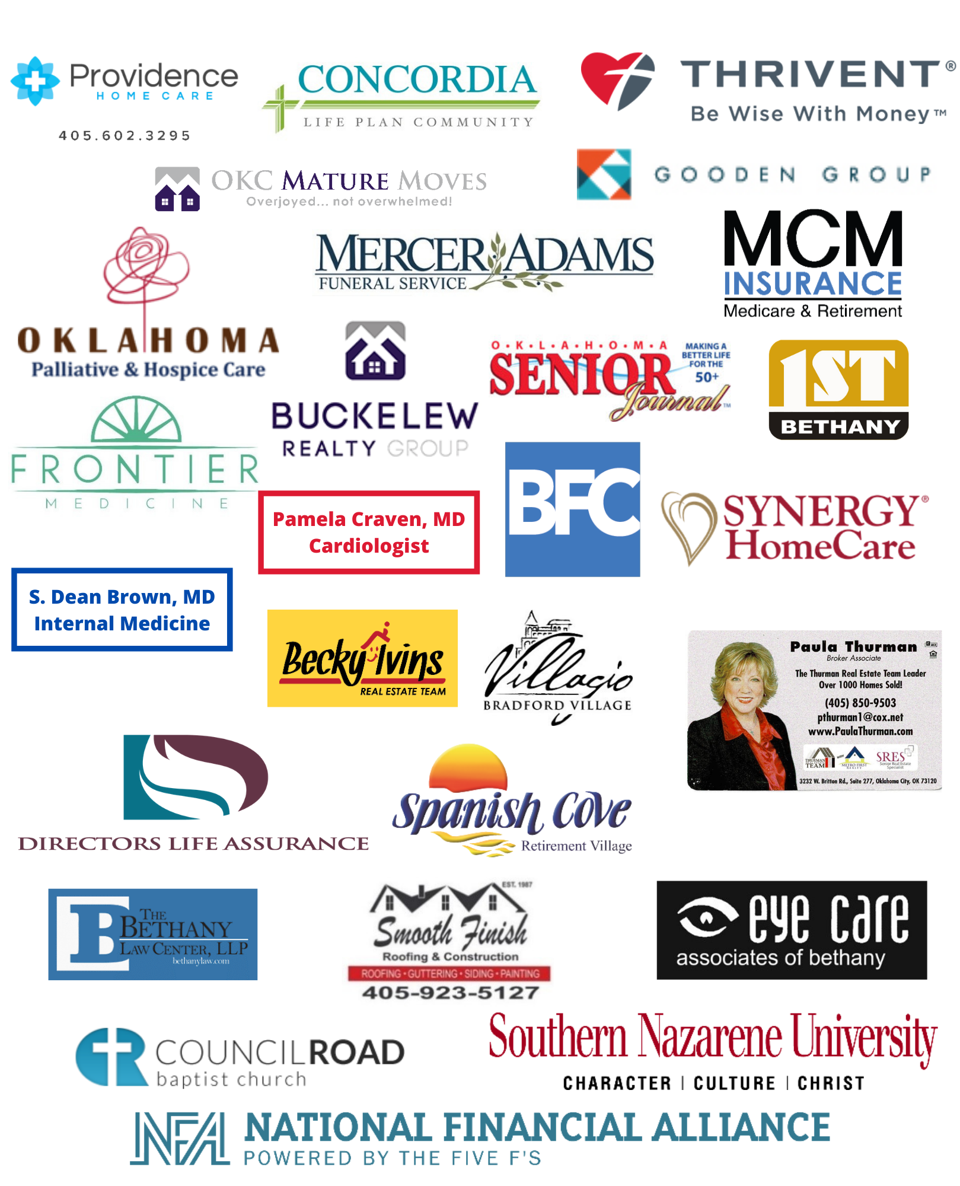
SPONSOR SPOTLIGHT

